Experiment report LAB-03
LAB-3-1: VLANIF CONFIGURATION
Answer the following questions:
Q3-1.1. Paste the screenshot of the created topology.
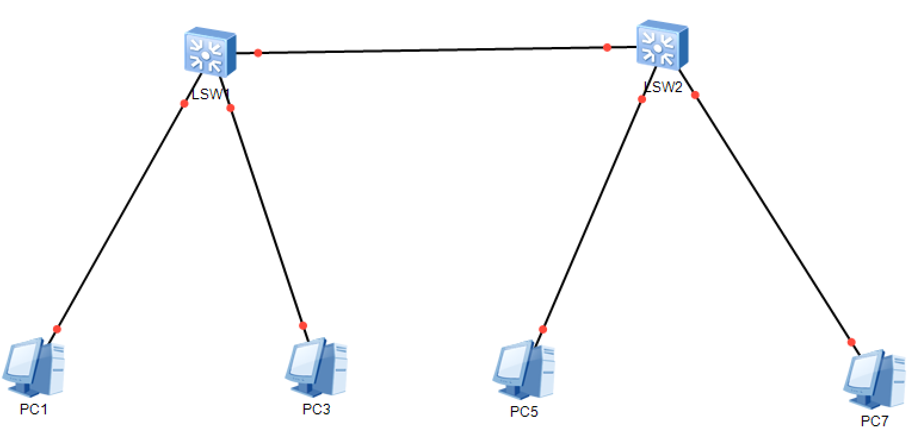
Q3-1.2. Paste the screenshot of the IP routing table on the switch LSW1.
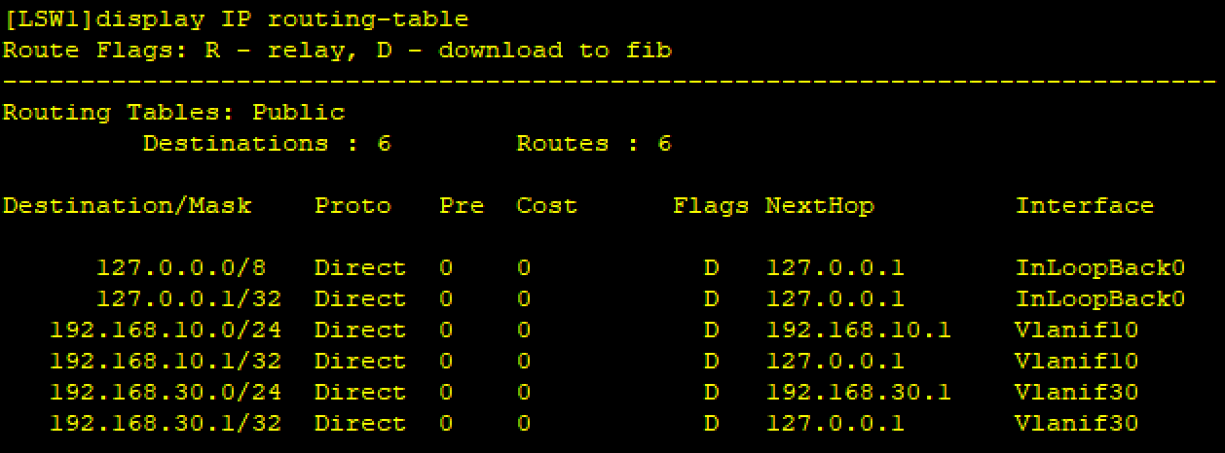
Q3-1.3. Can PC-10-1 and PC-10-3 ping each other? Please paste the screenshot of the ping result.
Yes, they can ping each other.
Here is the screenshot of the results.
Ping 10-3 from 10-1.
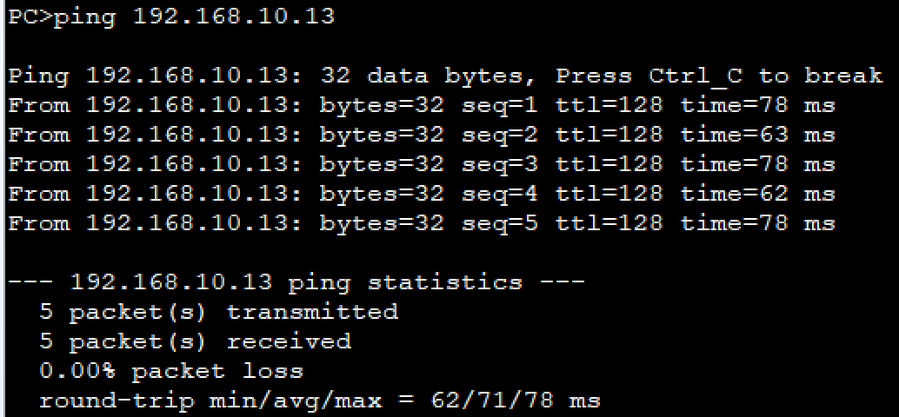
Ping 10-1 from 10-3.
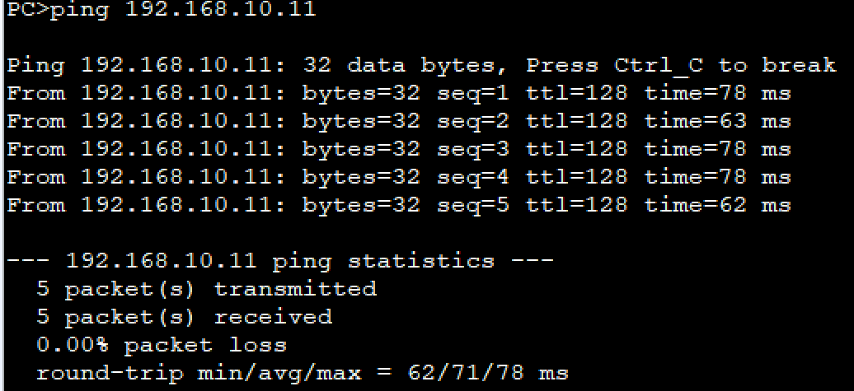
Q3-1.4. Can PC-30-1 and PC-30-3 ping each other? Please paste the screenshot of the ping result.
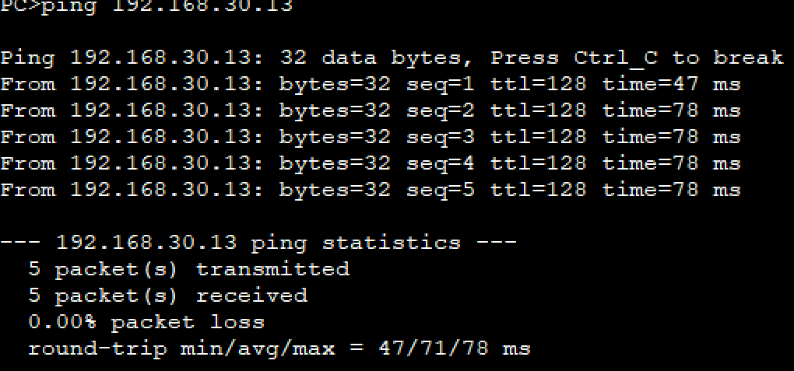
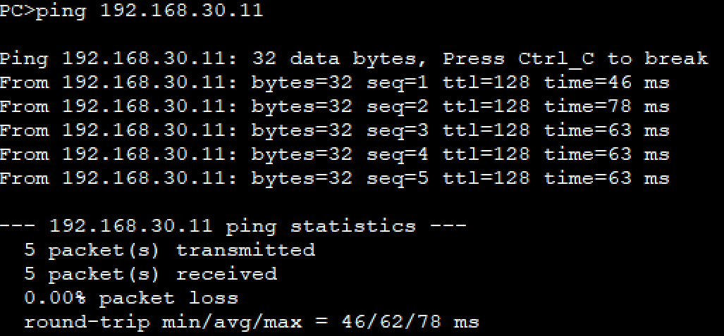
Q3-1.5. Can PC-10-1 and PC-30-3 ping each other? Please paste the screenshot of the ping result.
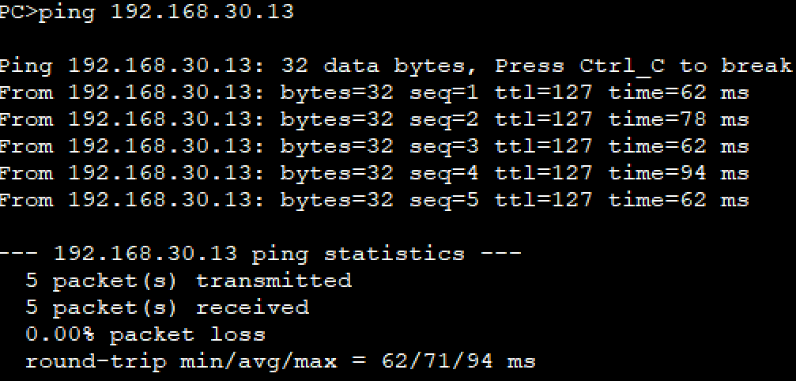
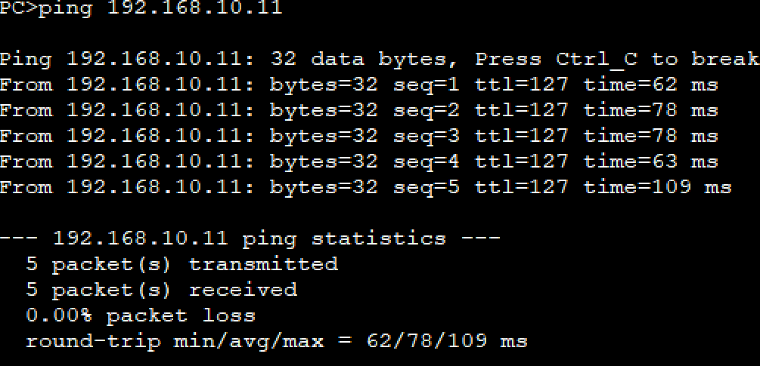
Q3-1.6. Please paste the screenshot of the result of command “tracert 192.168.30.13” issued from PC-10-1.
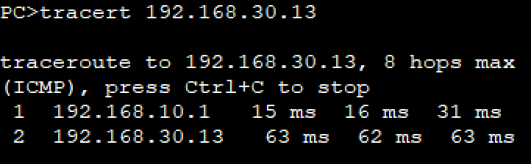
Q3-1.7. Analyze the captured ping traffics between the PC-10-1 and PC-10-2. What are the tagged VLAN IDs of the Ethernet frames leaving and entering the port? Please paste the screenshot of the all field information of the captured Ethernet frame.
Tagged VLAN ID is 10.
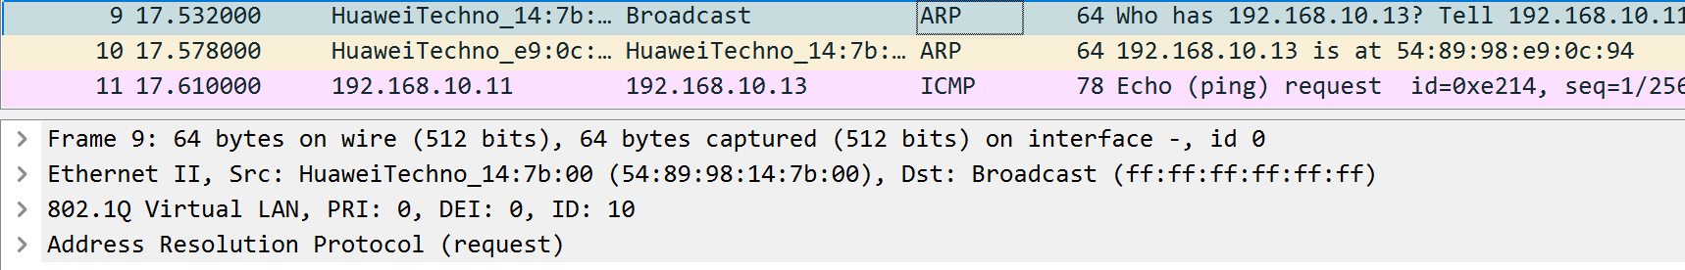
Q3-1.8. Analyze the captured ping traffics between the PC-10-1 and PC-30-2. What are the tagged VLAN IDs of the Ethernet frames leaving and entering the port? Please paste the screenshot of the all field information of the captured Ethernet frames.
Tagged VLAN ID is 30.
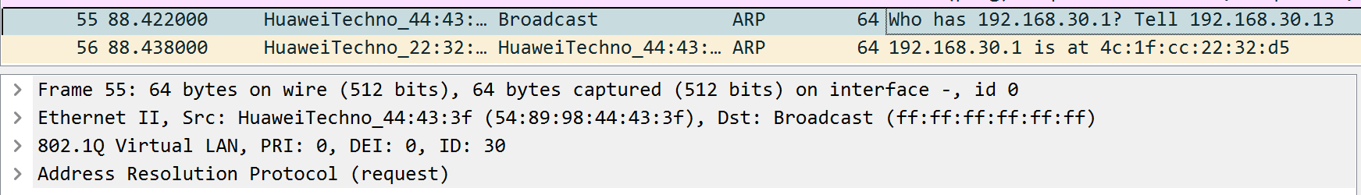
Comments
- Possible mistakes in the instruction paper.
In the page 5 , question 3-1.7 and 3-1.8, maybe there is something wrong, in my opinion, it should be PC 10-3 and PC30-3, because PC10-2 and PC 30-2 can be deleted in the former description.
(May 4, 2025)OK teacher reminded us to fix this error, my guess is right.
LAB-3-2: ONE-ARMED ROUTER CONFIGURATION
Answer the following questions:
Q3-2.1. Paste the screenshot of the created topology.
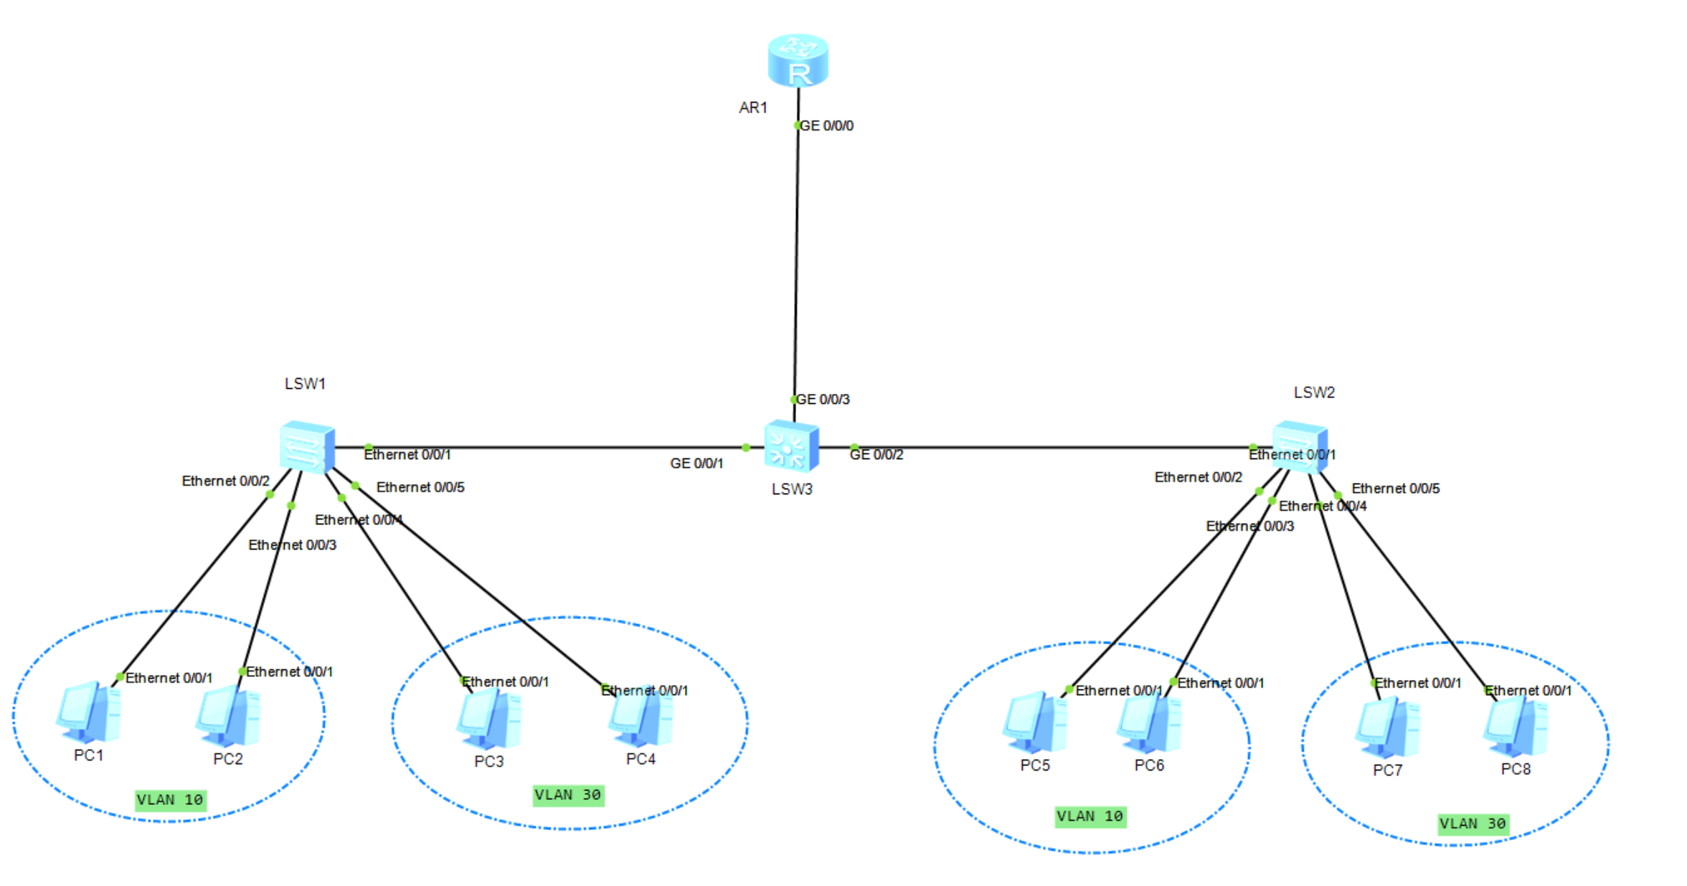
Q3-2.2. Paste the screenshot of the IP routing table on the router RTA.
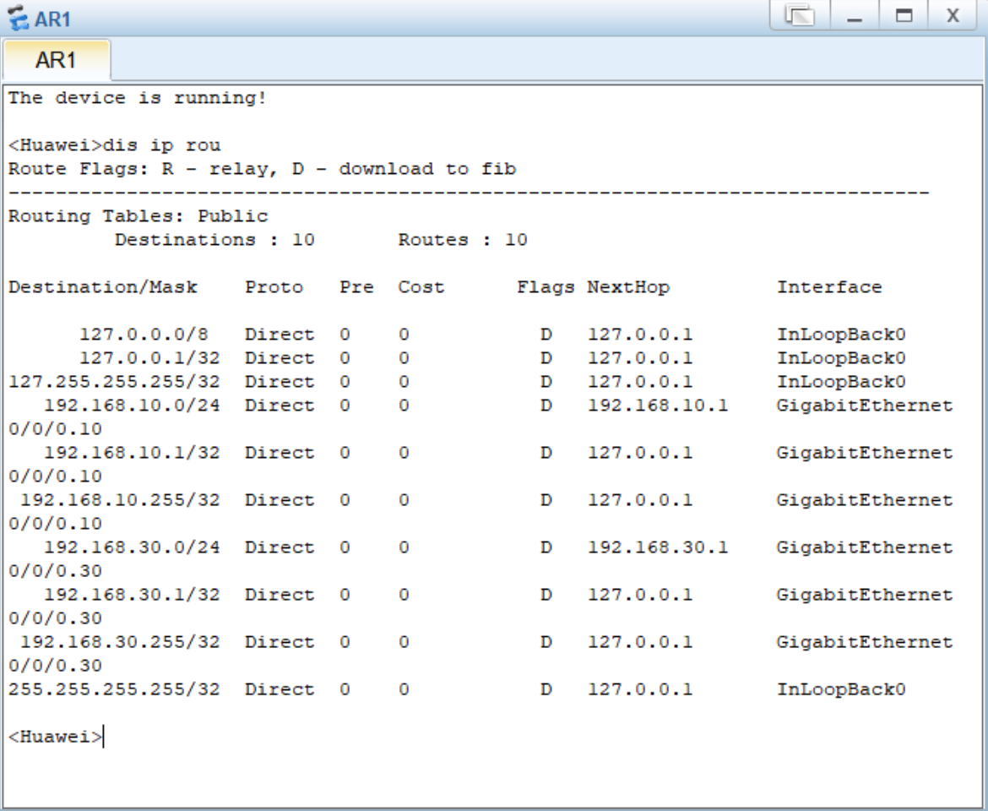
Q3-2.3. Can PC-10-1 and PC-10-3 ping each other? Please paste the screenshot of the ping result.
Yes, they can.
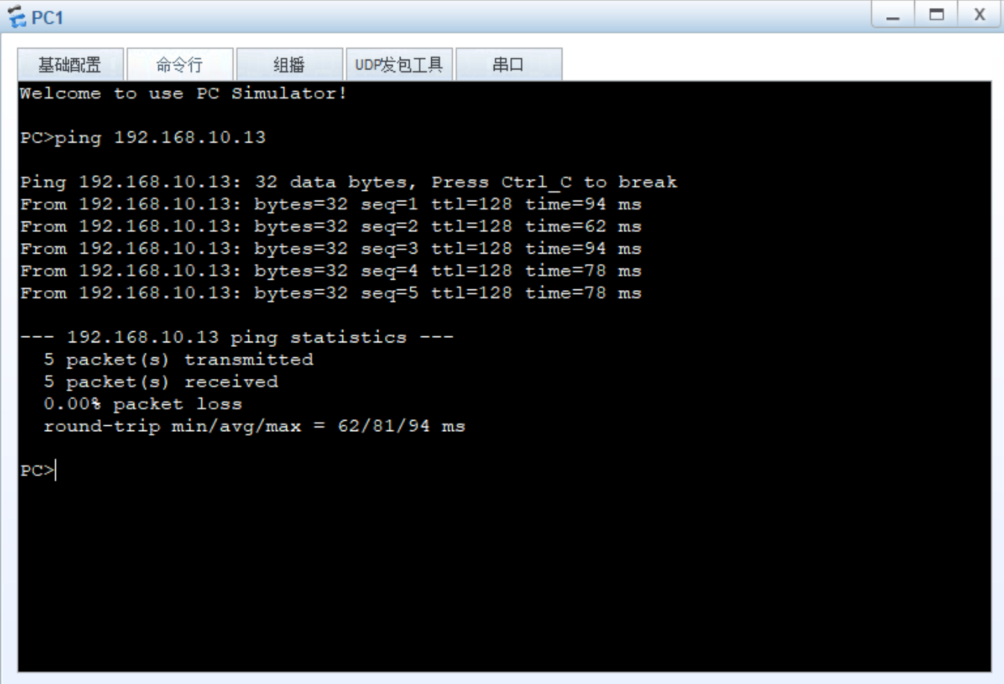
Q3-2.4. Paste the screenshot of the result of command “tracert 192.168.30.13” issued from PC-10-1.
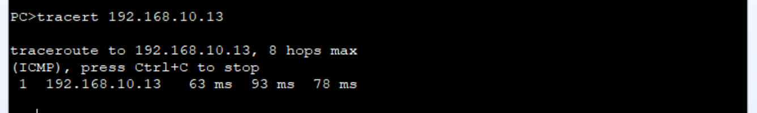
Q3-2.5. Analyze the captured ping traffics between the PC-10-1 and PC-10-2. What are the tagged VLAN IDs of the Ethernet frames leaving and entering the interface GE 0/0/2 on switch LSW3 ? Please paste the screenshot of the all field information of the captured Ethernet frame.
Vlan 10, because the ID= 10.
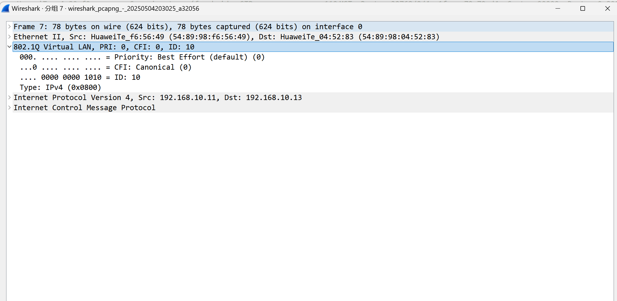
Q3-2.6. Analyze the captured ping traffics between the PC-10-1 and PC-10-2. What are the tagged VLAN IDs of the Ethernet frames leaving and entering the interface GE 0/0/24 on switch LSW3 ? Please paste the screenshot of the all field information of the captured Ethernet frame.
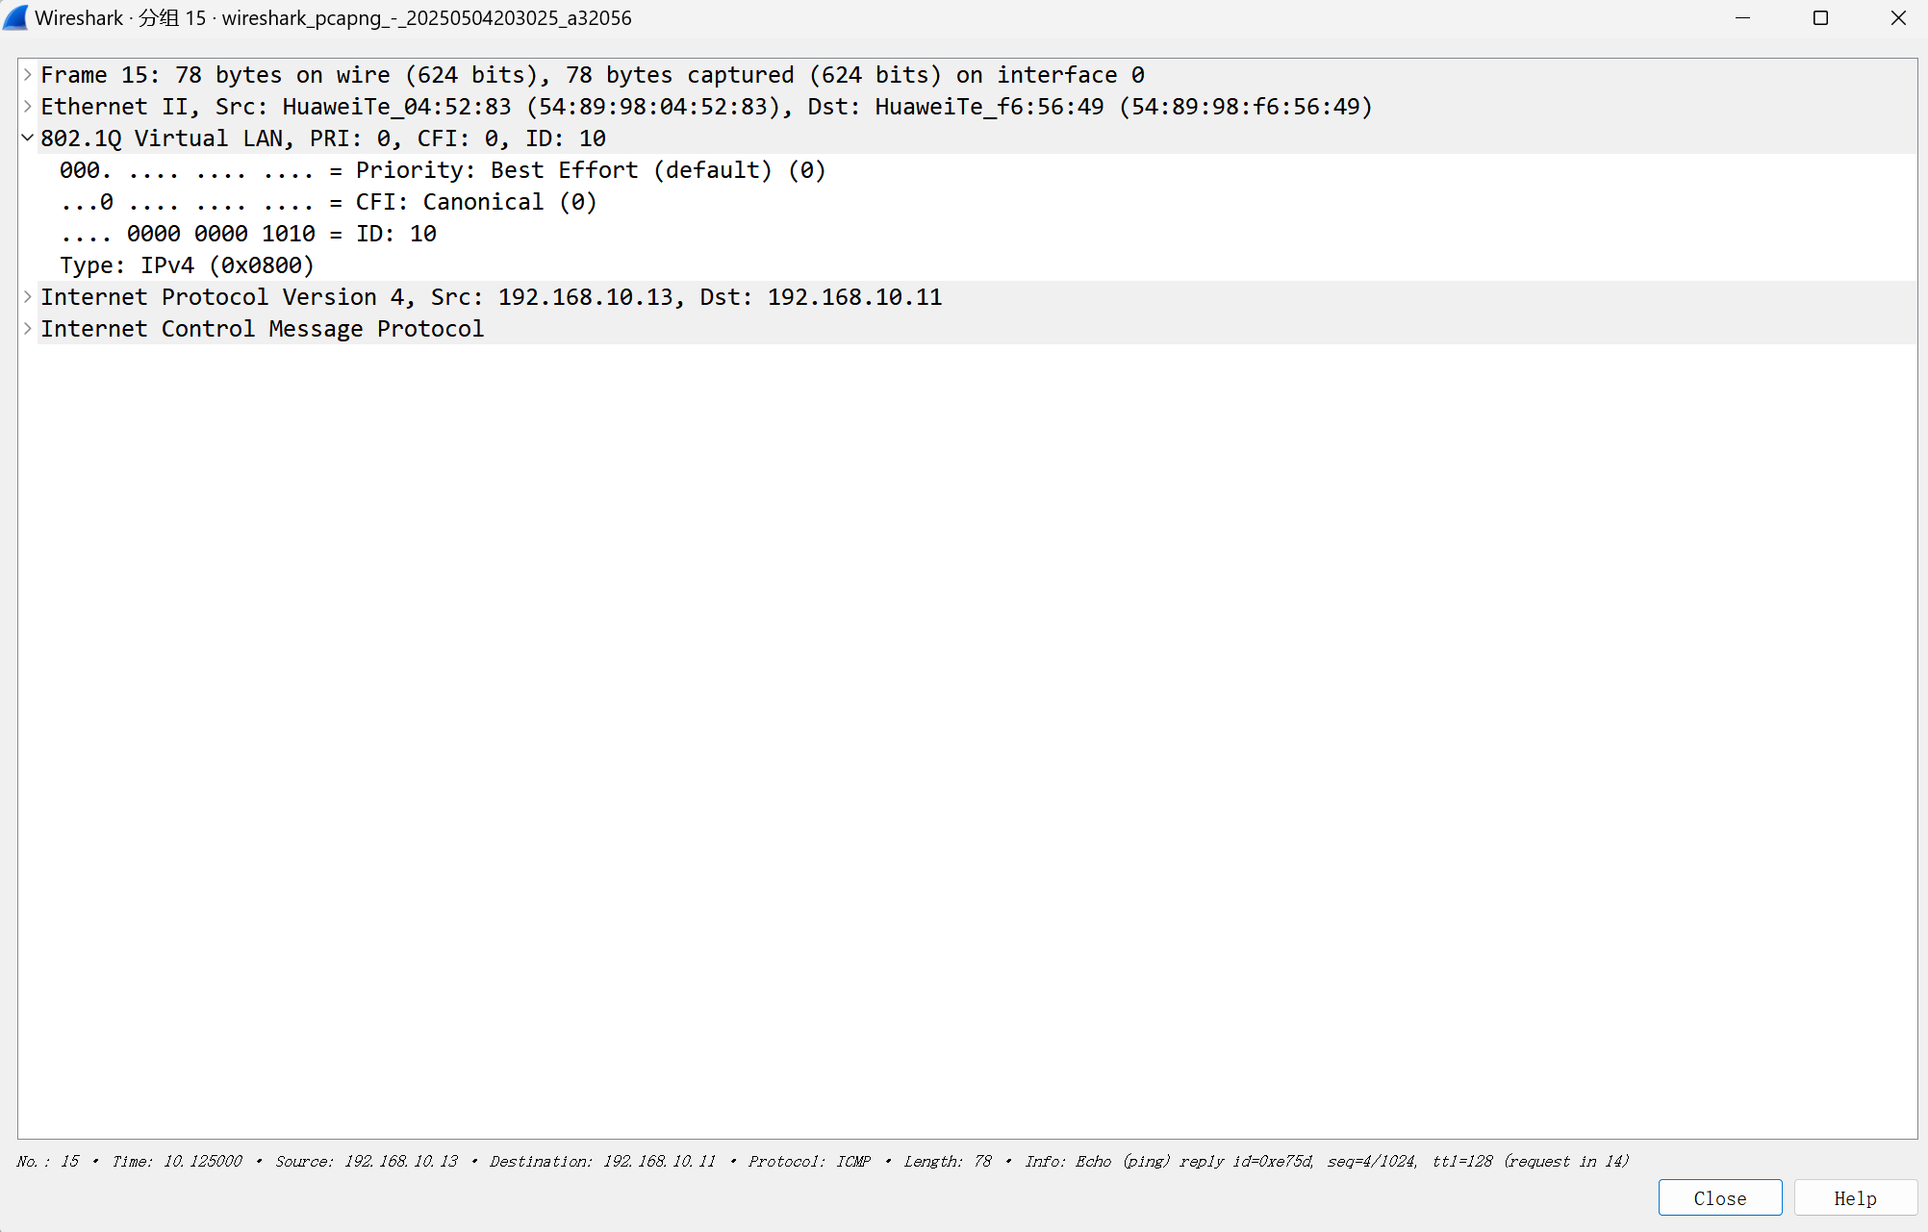
VLAN 10. Same reason as the last one.
Q3-2.7. Analyze the captured ping traffics between the PC-10-1 and PC-10-2. What are the tagged VLAN IDs of the Ethernet frames leaving and entering the interface GE 0/0/2 on router RTA? Please paste the screenshot of the all field information of the captured Ethernet frame.
VLAN 10.
